Prototype power consumption board

Inhoudsopgave

Schematic 2

Board 3

Partlist FARNELL 6

Recommandations 7

PCB order 7

Component order 7

Soldering 7

Testing 7

# Schematic

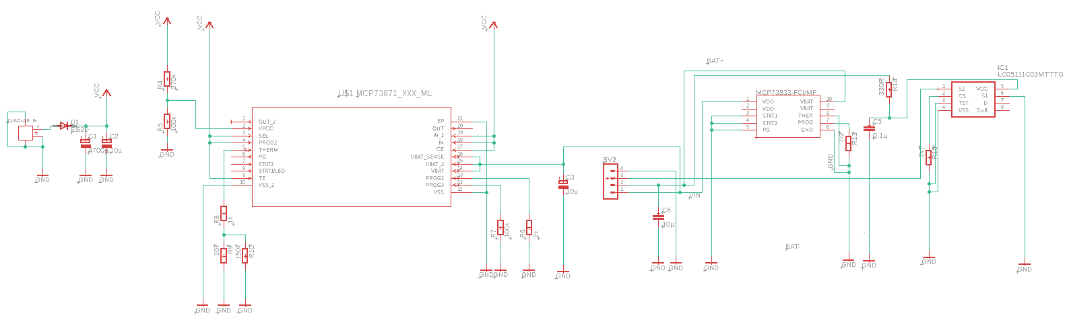

# Board

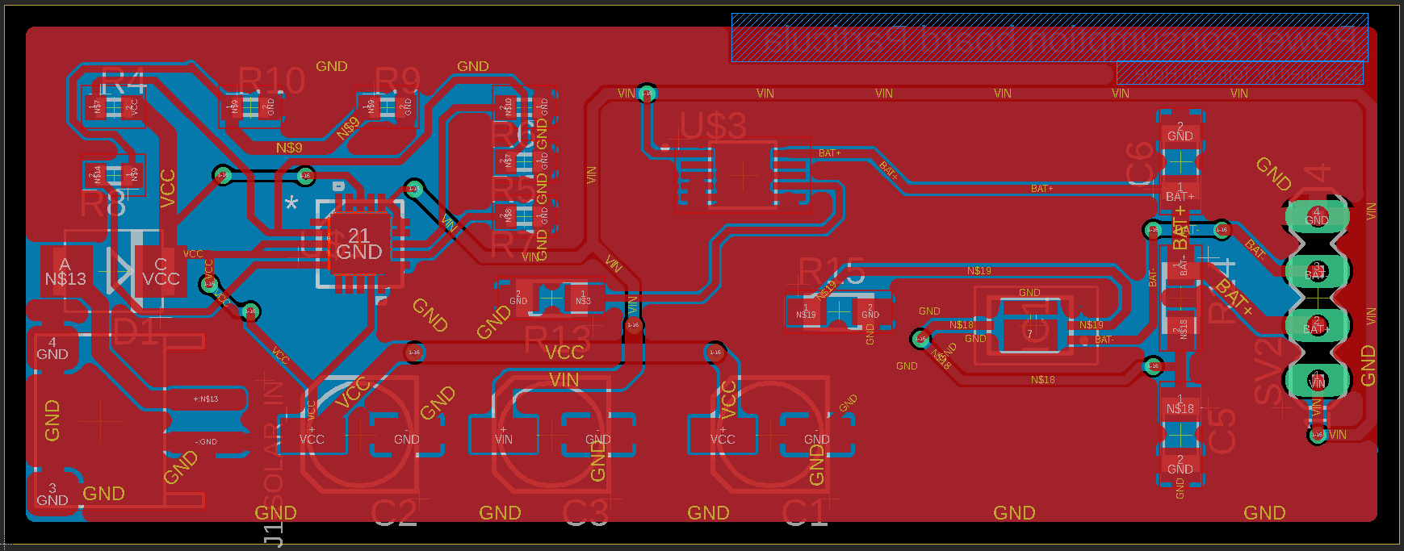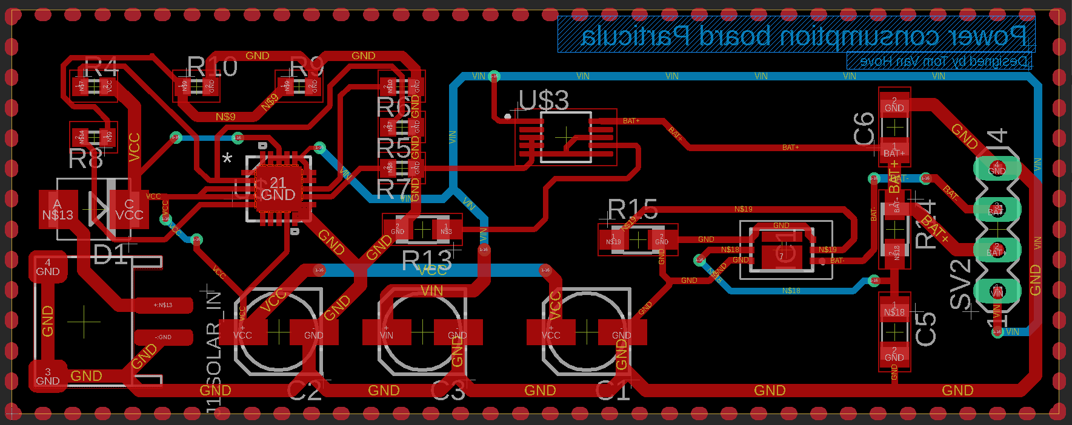

# Partlist FARNELL

|  |  |  |
| --- | --- | --- |
| Part | Value | FARNELL NR |
| C1 | 4700Âµ | 2346507 |
| C2 | 10Âµ | 9697012 |
| C3 | 10Âµ | 9697012 |
| C5 | 0.1Âµ | 2211074 |
| C6 | 10Âµ | 1907353 |
| D1 | ES2D | 1467491 |
| IC1 | LC05111C02MTTTG | 2728216 |
| J1-SOLAR_IN |  |  |
| R4 | 270k | 2447313 |
| R5 | 100k | 1692517 |
| R6 | 2k | 2447319 |
| R7 | 100k | 1692517 |
| R8 | 1k | 9238484 |
| R9 | 10k | 2861870 |
| R10 | 150k | 2447254 |
| R13 | 1k2 | 3254959 |
| R14 | 330R | 3254970 |
| R15 | 2k7 | 3254908 |
| SV2 |  | 1667510 |
| U$1 | MCP73871_XXX_ML | 1642489 |
| U$3 | MCP73833-FCI/MF | 1605576 |

# Recommandations

## PCB order

The ordering of the PCBs went very well. JLCPCB is an good site with fast shipping. The quality of them are very nice!

## Component order

We worked with Farnell because their fast shipping. Everything went well, all components are in stock and they were delivered very soon. But in multiple packets.

## Soldering

The soldering went great. We used only SMD. With the soldering station of VIVES it went very good! We used very small components because of available space on our PCB and we need to fit 3 PCBs in 1 single box with batteries.

I can make my PCB more smaller and that’s the next step after testing and debugging.

One mistake we made with the component order, we didn’t order an FLUX CLEANER so our PCB is a bit dirty right now. The final PCB will be clean.

## Testing

I tested the PCB only with a solarpanell and without batteries. And I got a voltage measure of 4.2V what is very nice!

After that step I loaded some batteries and the PCB stop charging when the batteries are 3.7V loaded. I’m not sure that that would be enough for feeding the NUCLEO and other hardware. Maybe I can place 2 batteries serial, but my pcb won’t work anymore. I can place them parallel too, for more capacity.

After charging the batteries, I discharged them with an ventilator (just a consumer, it could be anything). The ventilator worked 22 hours, non stop.

After this I recharged 1 battery …

TODO